

**CIRCUIT ANALISIS REPORT**

ABDELKERIM SEM ALI

2010205665

* *Experiment 1 (Deney 1): Proteus ISIS Program*

Proteus ISIS is a simulation program developed by Labcenter Electronics that allows electrical and electronic circuits to be designed and analyzed visually. The program provides a virtual working environment where components can be placed, connected, measured, and tested without the need for physical hardware. This experiment introduces the user to the Proteus ISIS interface and its basic functions, which will be used extensively in later circuit analysis experiments.experiments.

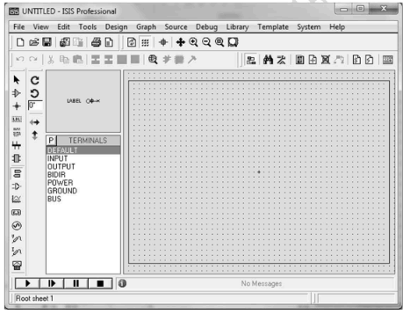

* a – Selection mode: You can connect, move, change the direction or delete the materials on the work screen.
* b – Component mode: Materials to be used in electrical or electronic circuits are selected.
* c – Terminal mode: It is used to carry the chassis (GROUND) to the work screen.
* d – Generator mode: It is used to add a power supply to the work screen.
* e – Voltage probe: It works as a voltage probe. It is connected to the line to be measured on an established circuit. It shows the voltage on the line while the program is running.
* f – Current probe: It works as a flow probe. It is connected to the line to be measured on an established circuit. It shows the current passing through the line while the program is running.
* g – Virtual Instruments Mode: There are measuring instruments such as oscilloscope, AA (alternating current), DA (direct current) voltmeter and ammeter.
* Experiment 2 (Deney 2 ) Breadboard, Avometer-Multimeter Usage
* Breadboard Internal Connections

The internal electrical connections of a breadboard are illustrated in Figure 2.2.

The A and D rails are used for supplying power and are connected vertically.

The B and C rows are used for component connections and are connected horizontally.

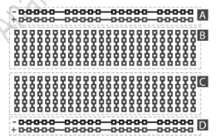 . Fig 2.2 electrical connection

In long breadboards, the power rails may be divided into two separate sections, as shown in Figure 2.3. This separation must be considered when supplying voltage to avoid unintentional open circuits.

* Examples of correct and incorrect breadboard connections are shown in:

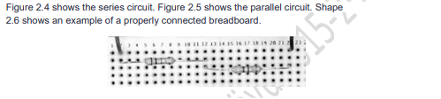 . Figure 2.4: Series circuit example

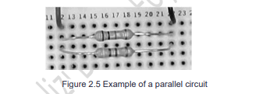 . Figure 2.5: Parallel circuit example

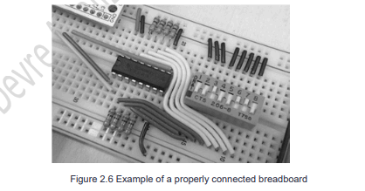

Figure 2.6: Properly connected breadboard

* Avometer (Multimeter) Introduction

An avometer is a measuring device used to measure current (A), voltage (V), and resistance (Ω). Modern avometers, also called multimeters, can also measure diode status, continuity, frequency, and other parameters.

A typical digital multimeter used in the experiment is shown in Figure 2.7. The multimeter consists of:

* A commutator switch for selecting the measurement type and range
* Probe terminals (COM, V, Ω, mA, 10A)
* A digital display

The black probe is always connected to the COM (ground) terminal, while the red probe is connected according to the type of measurement.

* Voltage Measurement To measure voltage:
* The black probe is connected to COM
* The red probe is connected to the V terminal
* The multimeter is connected in parallel with the component
* **Voltage Measurement**

To measure voltage:

* The black probe is connected to **COM**
* The red probe is connected to the **V terminal**
* The multimeter is connected **in parallel** with the component

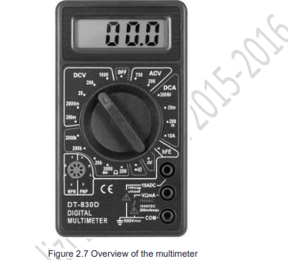 Fig 2.7 Multimetre

* Resistor Color Codes

There are colored lines on the resistor indicating the size and tolerance of the resistor. It usually has 4 stripes. Some resistors have 5 lines. Specifies discrete line tolerance. If the resistance is held with the tolerance line on the right side, the codes are Figure As shown in 2.10. The color equivalents of the resistors are given in Table 2.4.

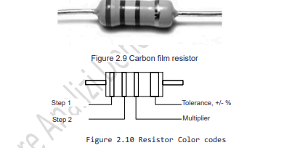

Fig 2.10 Resistor color Codes

* Example of resistance:

Let the colors on the resistance be red, red, yellow, gold. Resistance calculation = 2 2 x 104 = 220k ± 5%. Let the colors on the resistor be brown, black, black, black, silver. Resistance calculation = 1 0 0 x 100 = 100Ohm ± 10%.

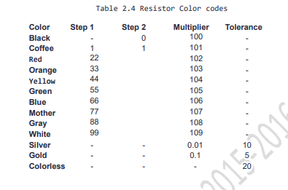

* Experiment 3 (DENEY 3) Voltage, Current Measurement in Direct Current Circuits and Kirchoff's Application of Voltage, Current Law
* Experiment A(Deney A)
* A1-) Şekil 3.1’de verilen devreyi breadboard üzerine kurunuz.

Vb = 9V (9V’luk pil)

R1 = 4.7k

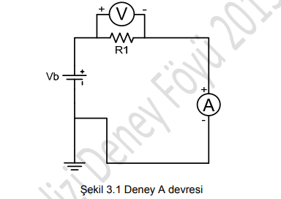

Şekil 3.1 Deney A devresi

* SOLUTION

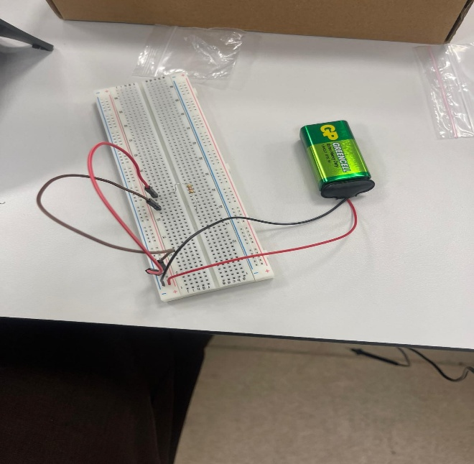 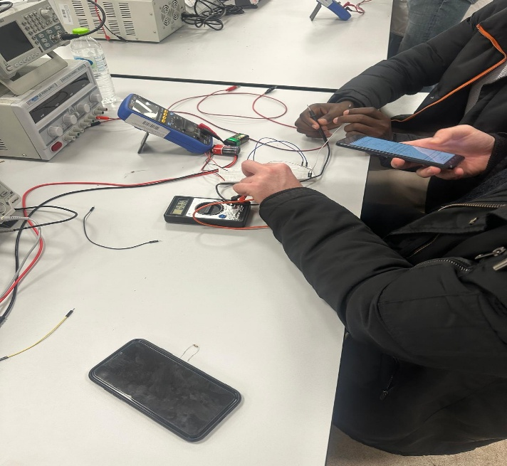

* **Procedure**

1. The circuit shown in **Figure 3.1** was assembled on the breadboard using a **9 V DC source** and a **4.7 kΩ resistor**.
2. The voltage across resistor R1 was measured by connecting the multimeter **in parallel**, as shown in **Figure 3.2**.
3. The current flowing through resistor R1 was measured by connecting the multimeter **in series**, as shown in **Figure 3.3**.
4. Measurement ranges were adjusted to display sufficient decimal precision.
5. The measured values were recorded in **Table 3.1**.

* A2-) R1 direnci üzerindeki gerilimi ölçmek için avometreyi Şekil 3.2’deki gibi bağlayınız. Virgülden sonra iki haneyi görecek şekilde komütasyonu ayarlayınız.

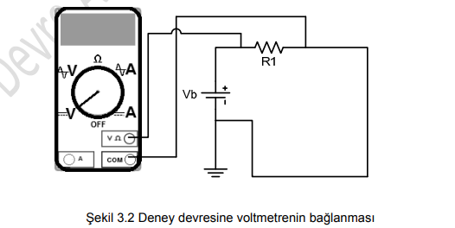

Şekil 3.2 Deney devresine voltmetrenin bağlanması

* SOLUTION

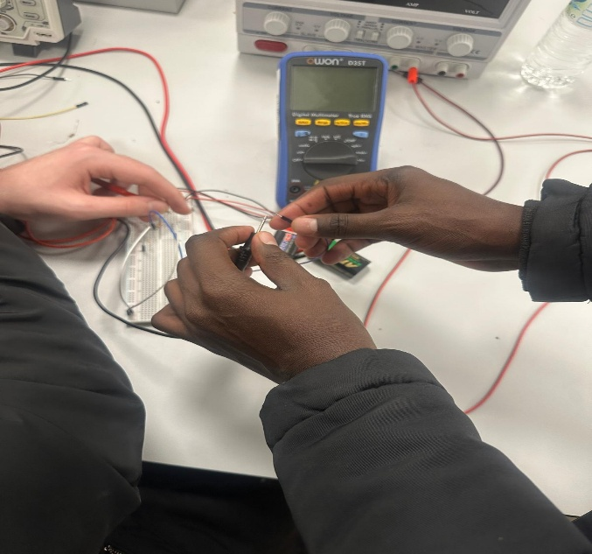 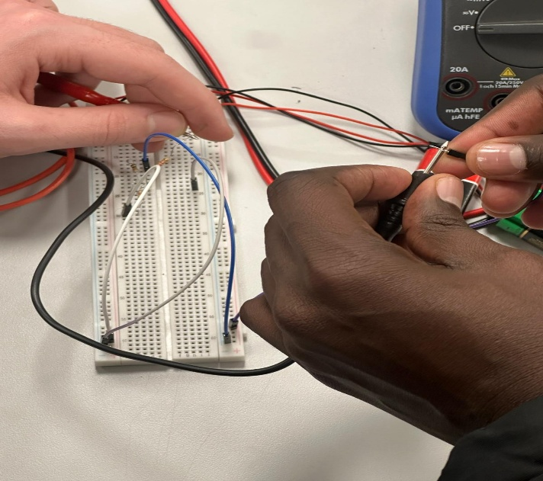

* A3-) R1 direnci üzerinden geçen akımı avometreyi Şekil 3.3’deki gibi bağlayınız. Virgülden sonra 3 basamak görülecek şekilde komütasyonu ayarlayınız
* SOLUTION

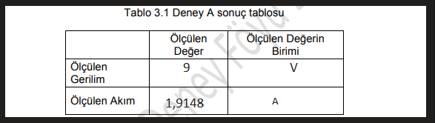

V=IxR= 1,9148x4,7 = 9V I=V/R= 9/4,7= 1.9148

The measured voltage and current values were consistent with Ohm’s Law. Using the measured current and resistance value, the calculated voltage closely matched the measured voltage, with minor deviations attributed to internal resistance of the battery and measurement tolerances.

* Experiment B (Deney B)

Doğru akım devrelerinde Kirchoff’un gerilim kanununun uygulanması

* B1-) Şekil 3.4’ de verilen devreyi kurunuz

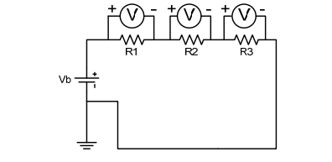

* R1 = 4.7k, R2 = 10k, R3 = 22k Vb = 9V (9V’luk pil)
* SOLUTION

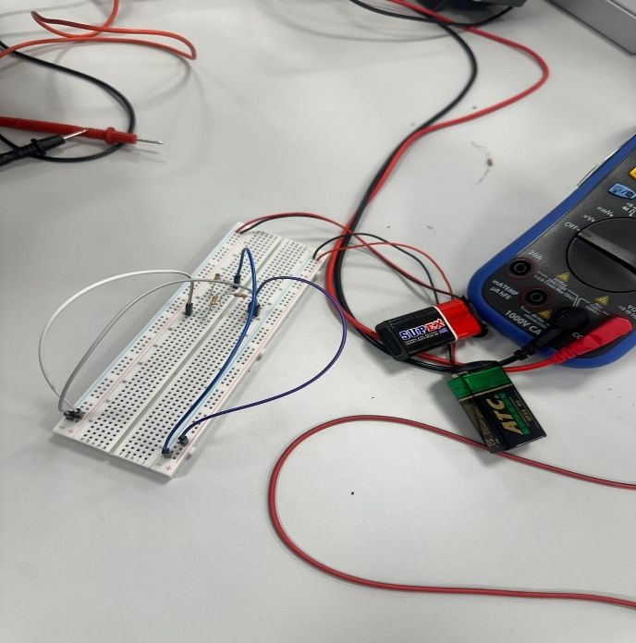 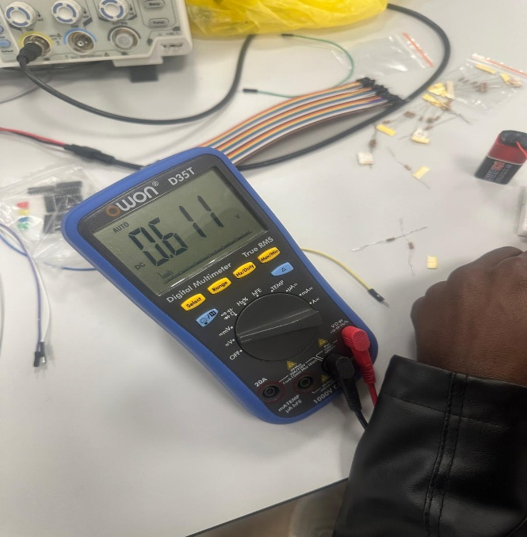

B2-) Avometrenizle sırayla R1 R2 ve R3 üzerindeki gerilimleri ölçünüz. Ölçüm sonuçlarını Tablo 3.2’ye kaydediniz. Komütasyonun en hassas kademede olduğuna emin olunuz. Birimleri yazmayı unutmayınız.

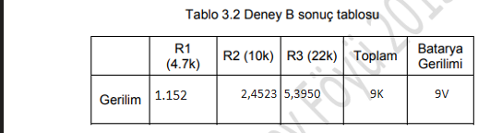

Doğru akım devrelerinde Kirchoff’un akım kanununun uygulanması İşlem Basamakları

* C1-) Şekil 3.5’de verilen devreyi kurunuz. R1 = 4.7k, R2 = 10k, R3 = 22k Vb = 9V (9V’luk pil)

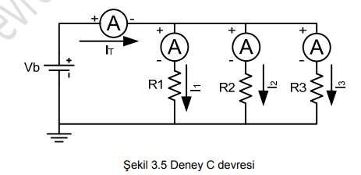

* SOLUTION

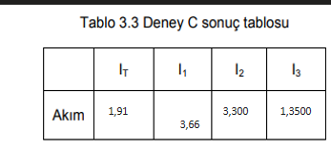

* Experiment 4 DENEY (4): Analysis of Direct Current Circuits by Mesh Method

1- Experimental Procedure The circuit shown in Figure 4.1 was assembled on the breadboard using the given resistor values and a 9 V DC source.

2- Mesh currents I₁, I₂, and I₃ were measured sequentially using the current measurement mode of the avometer.

3-Measurement ranges were adjusted to the most sensitive level to obtain accurate readings.

4-Voltages across resistors R1, R2, R3, and R4 were measured using the voltmeter mode of the avometer.

5-All measured values were recorded in Table 4.1.

* Equipment Used Breadboard
* DC power supply (9 V battery)
* Resistors:
* R1 = 4.7 kΩ
* R2 = 10 kΩ
* R3 = 22 kΩ
* R4 = 2.2 kΩ
* Avometer (multimeter)
* Connecting wires

Mesh (Ambient Current) Method The mesh current method is a systematic technique used to analyze planar circuits by assigning hypothetical loop currents to each independent loop. Kirchhoff’s Voltage Law (KVL) is applied to each loop to form a set of linear equations.

* 1-) Set up the experimental circuit given in Figure 4.1.

R1 = 4.7K, R2 = 10K, R3 = 22K, R4 = 2.2K Vs = 9V (9V)

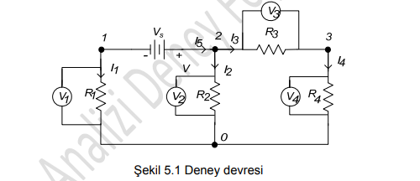

* Experimental Procedure The circuit shown in Figure 4.1 was assembled on the breadboard using the given resistor values and a 9 V DC source.

Mesh currents I₁, I₂, and I₃ were measured sequentially using the current measurement mode of the avometer.

Measurement ranges were adjusted to the most sensitive level to obtain accurate readings.

Voltages across resistors R1, R2, R3, and R4 were measured using the voltmeter mode of the avometer.

All measured values were recorded in Table 4.1.

* SOLUTION
* VOLTAJLARI ÖLÇÜLMESİ

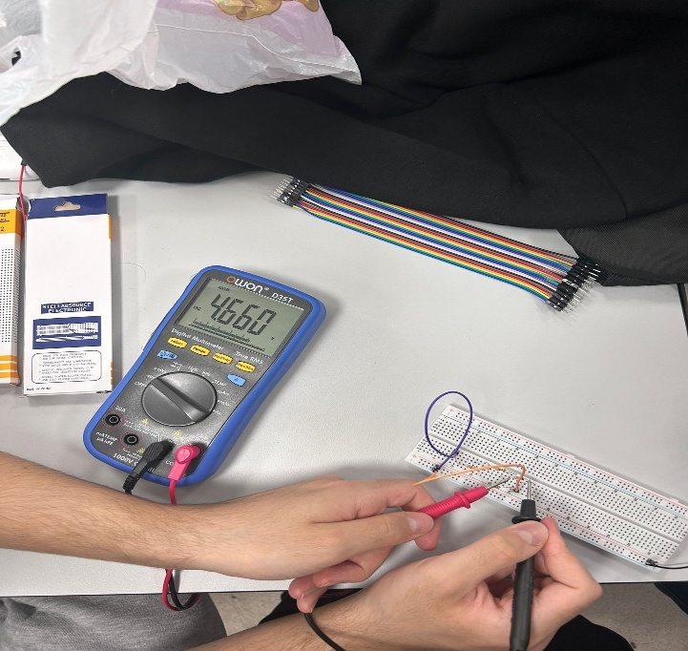 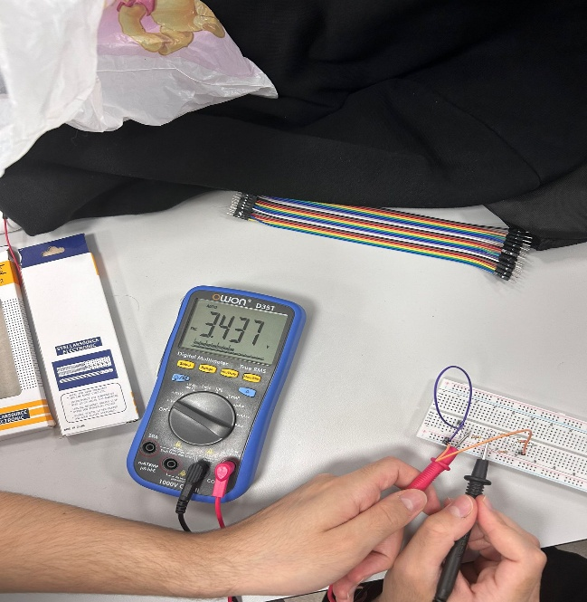

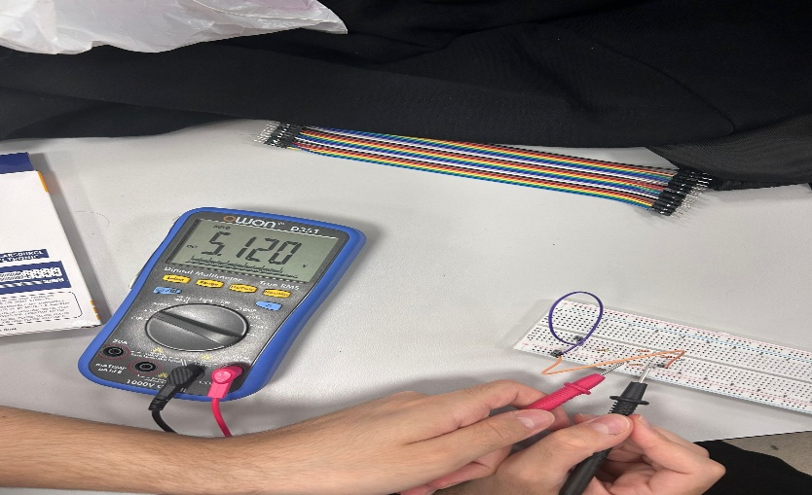

* AKIMLARI ÖLÇÜLMESİ

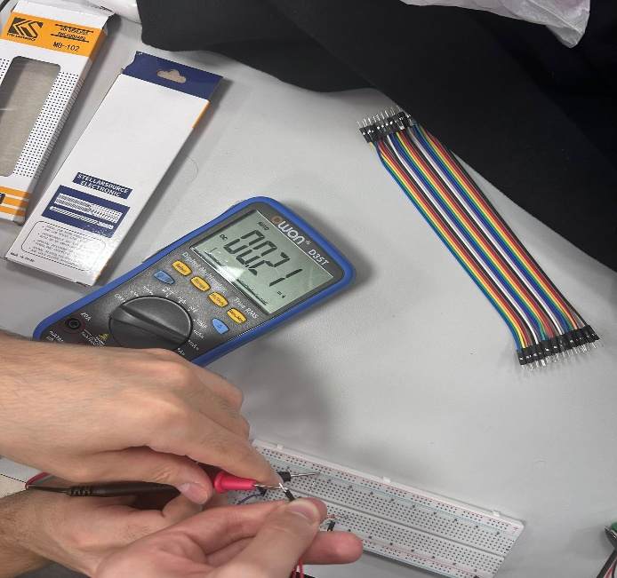 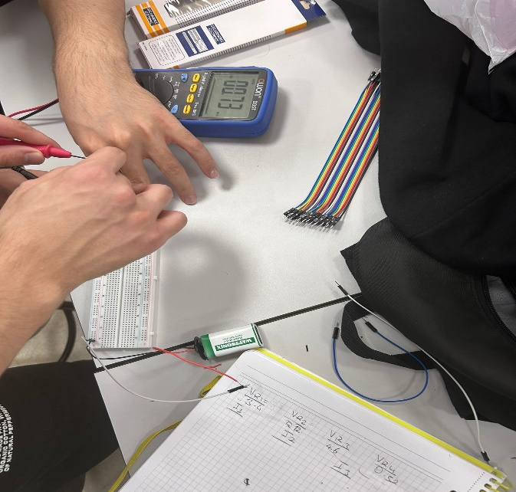

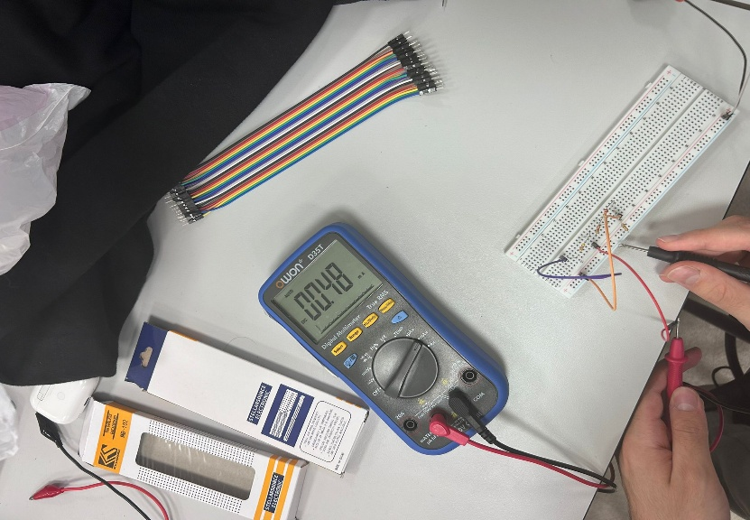

* 2-) Measure the ambient currents I1, I2 and I3 sequentially with the current stage of your avometer. Record the results in Table 4.1. Make sure that the commutation is at the most sensitive level. Do not forget to write the units.
* 3-) Measure the voltages on the resistors R1, R2, R3 and R4 with the voltmeter stage of your avometer, respectively. Record the results in Table 4.1. Make sure that the commutation is at the most sensitive level. Do not forget to write the units. Table 4.1 Experiment result table

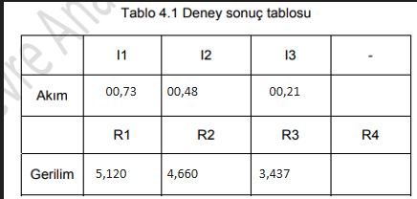

Conclusion: In this experiment, the mesh (ambient current) method was successfully applied to analyze a multi-loop DC circuit. The experimentally measured mesh currents and resistor voltages closely matched theoretical predictions. This confirms that the mesh current method is an effective and reliable technique for analyzing complex DC circuits.

* Experiment 5: Node Analysis Method in Direct Current Circuits

Objective :

The objective of this experiment is to analyze a direct current (DC) circuit using the node analysis method. Node voltages, branch currents, and resistor voltage drops are determined experimentally and used to verify the correctness of the node analysis technique.

Equipment Used

* Breadboard , DC power supply (9 V battery), Resistors:
* R1 = 4.7 kΩ, R2 = 10 kΩ , R3 = 22 kΩ , R4 = 2.2 kΩ.
* Avometer (multimeter)
* Connecting wires

Theory Node Analysis Method The node analysis method is based on Kirchhoff’s Current Law (KCL) and is used to analyze circuits by solving for node voltages with respect to a reference node (ground).

For each node (except the reference node), a KCL equation is written in terms of node voltages and resistances. Once node voltages are determined, branch currents and voltage drops across components can be calculated using Ohm’s Law.

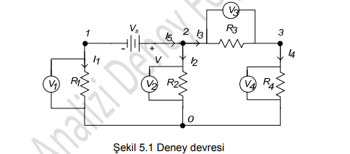

Experimental Procedure The circuit shown in Figure 5.1 was assembled on the breadboard using the given resistor values and a 9 V DC source.

The currents I₁, I₂, and I₃ were measured sequentially using the current measurement mode of the avometer.

Measurement ranges were set to the most sensitive level to obtain accurate readings.

The voltages between the following node pairs were measured using the voltmeter mode of the avometer:

* Node 1 – Node 0
* Node 1 – Node 2
* Node 2 – Node 0
* Node 2 – Node 3
* Node 3 – Node 0

Voltages across resistors R1, R2, R3, and R4 were also measured.

All results were recorded in Table 5.1.

Results Table 5.1 – Experiment 5 Results Measured Currents

Current Value Unit I₁ A I₂ A I₃ A

Measured Node Voltages

Node Pair Voltage (V) 1 – 0 1 – 2 2 – 0 2 – 3 3 – 0

Measured Resistor Voltages

Resistor Voltage (V) R1 R2 R3 R4

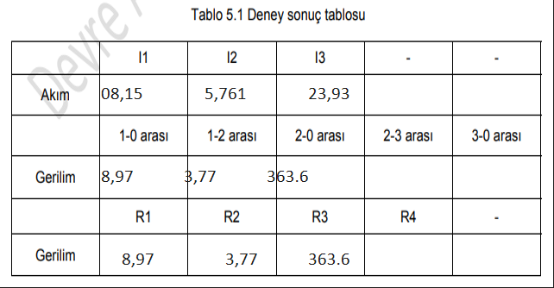

* SOLUTION

1-For current measurement

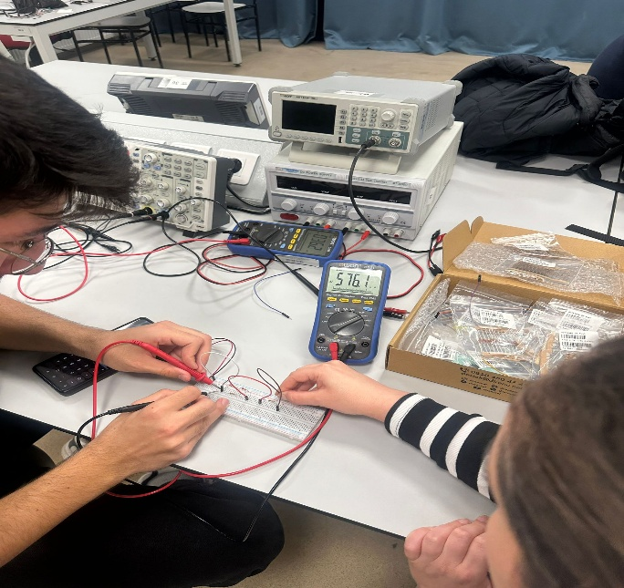 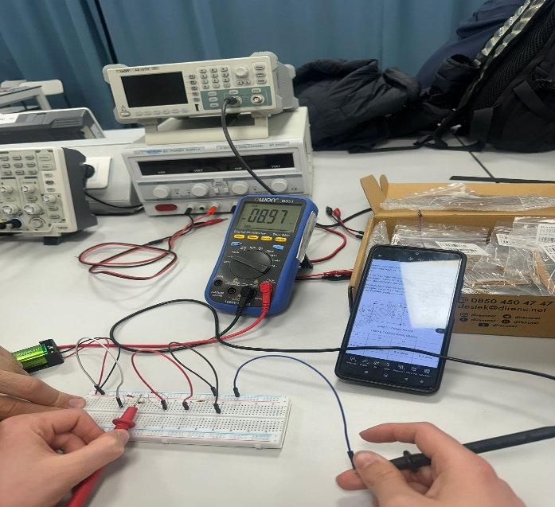

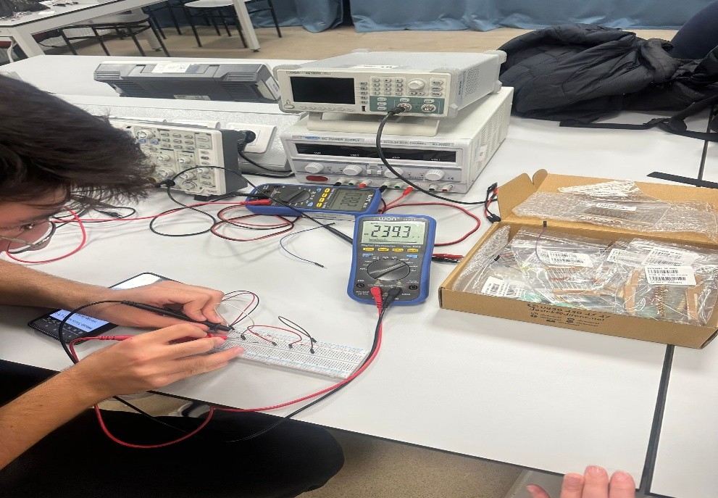

2- For current measurement

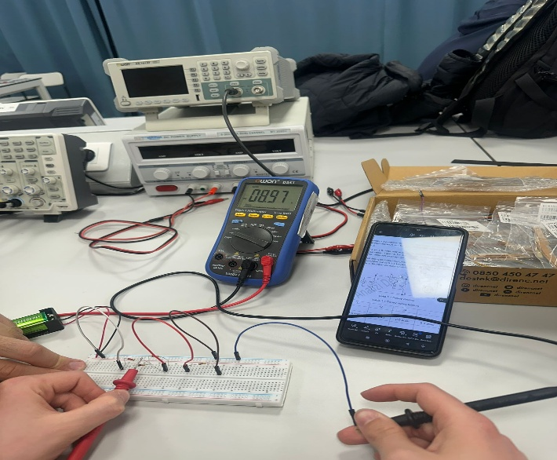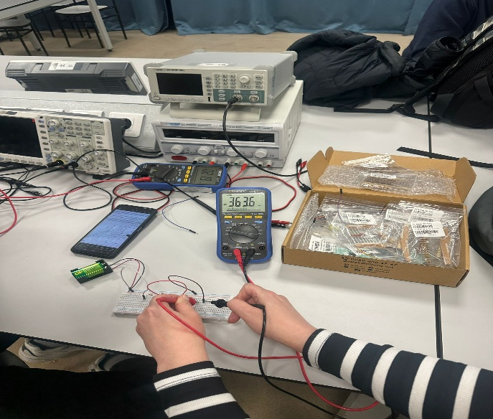

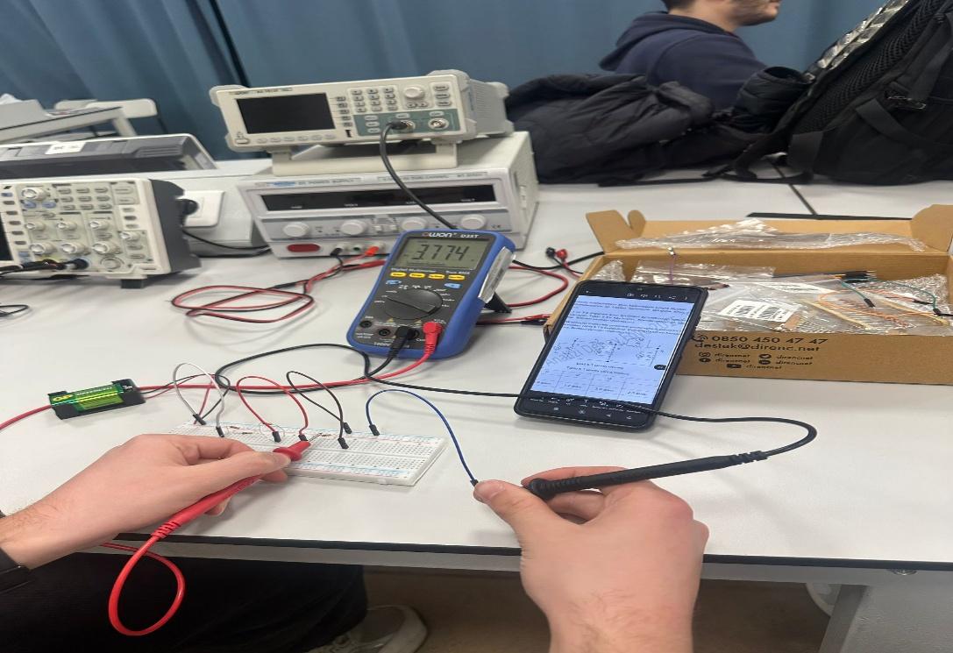

Analysis and Discussion Using the node analysis method, KCL equations were written at the circuit nodes with respect to the reference node. The experimentally measured node voltages were consistent with the theoretical behavior predicted by node analysis.

Once node voltages were known, branch currents and resistor voltage drops were calculated using Ohm’s Law and compared with measured values. The close agreement between calculated and measured results confirms the validity of the node analysis method.

Minor discrepancies may be attributed to resistor tolerances, internal resistance of the power source, and measurement uncertainty of the multimeter.

Conclusion

In this experiment, the node analysis method was successfully applied to a DC circuit. Node voltages, branch currents, and resistor voltage drops were accurately measured and analyzed. The results verified Kirchhoff’s Current Law and demonstrated that node analysis is an efficient and reliable technique for solving complex DC circuits.

* Experiment 6: Analysis of Direct Current Circuits Using the Superposition Method

Objective :

The objective of this experiment is to analyze a linear direct current (DC) circuit using the superposition method. The individual effects of multiple independent voltage sources on circuit currents and voltages are measured separately and then combined to verify the superposition principle.

* Equipment Used
* Breadboard , DC voltage sources (E₁ = 9 V, E₂ = 9 V)
* Resistors: R1 = 4.7 kΩ R2 = 10 kΩ R3 = 22 kΩ
* Avometer (multimeter)
* Connecting wires
* Superposition Method:

The superposition method states that in a linear circuit with multiple independent sources, the current or voltage in any element is equal to the algebraic sum of the currents or voltages produced by each independent source acting alone.

To apply superposition:

When analyzing one voltage source, all other independent voltage sources are deactivated and replaced by short circuits.

Each source’s contribution is calculated independently.

The total response is obtained by summing the individual contributions.

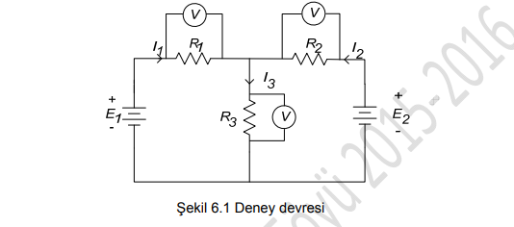

* Experimental Procedure

Part 1:

* Both Sources Active The circuit shown in Figure 6.1 was assembled with both voltage sources E₁ and E₂ active.
* Currents I₁, I₂, and I₃ were measured using the current measurement mode of the avometer.
* Voltages across resistors R1, R2, and R3 were measured.
* The measured values were recorded in Table 6.1 under “E₁ and E₂ Active”.

Part 2:

* Only Source E₁ Active Voltage source E₂ was deactivated and replaced with a short circuit.
* Currents I₁, I₂, and I₃ were measured again.
* Voltages across R1, R2, and R3 were measured.
* The results were recorded in Table 6.1 under “E₁ Active”.

Part 3:

* Only Source E₂ Active Voltage source E₁ was deactivated and replaced with a short circuit.
* Currents I₁, I₂, and I₃ were measured.
* Voltages across R1, R2, and R3 were measured.
* The results were recorded in Table 6.1 under “E₂ Active”.
* SOLUTIONS :

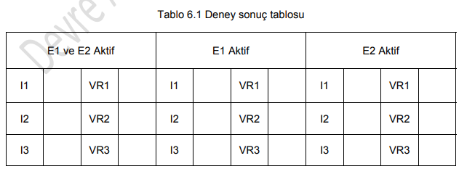

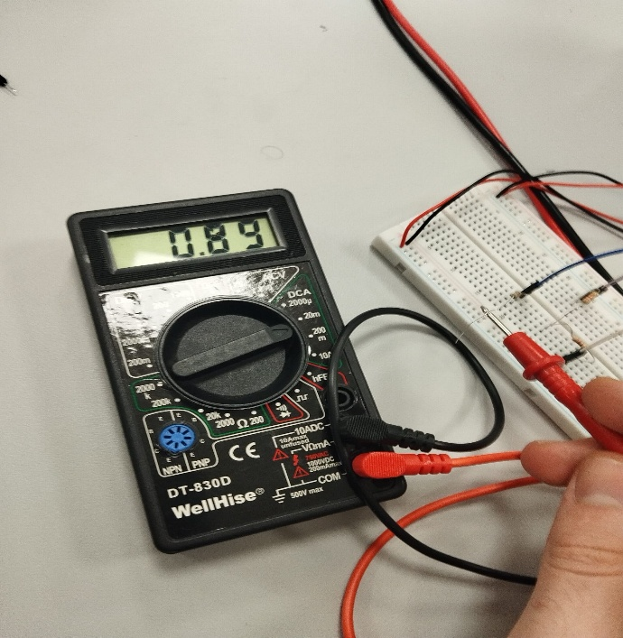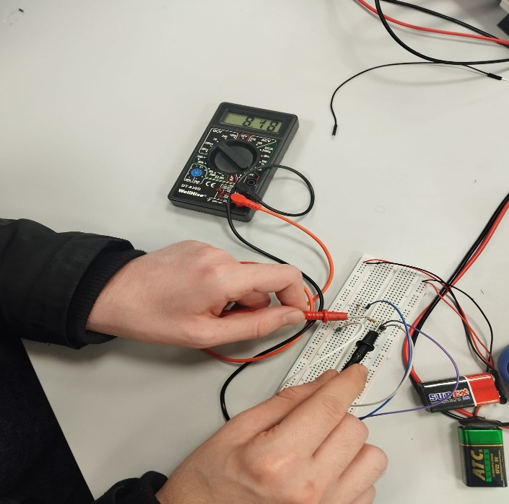

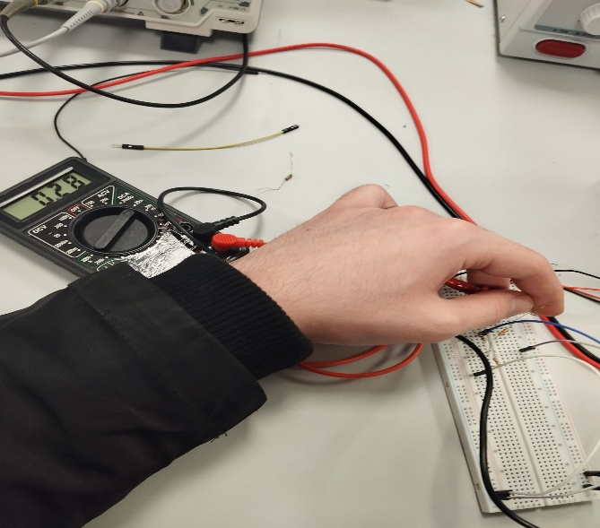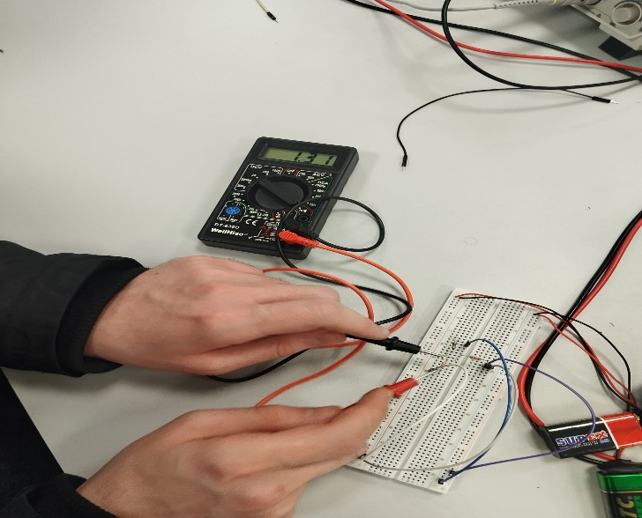

* Analysis and Discussion According

to the superposition principle, the total current or voltage in each circuit element should be equal to the sum of the individual contributions from each independent source.

The experimental results confirm this principle. The measured currents and voltages when both sources were active closely matched the algebraic sum of the values obtained when E₁ and E₂ were considered separately. Small discrepancies can be attributed to resistor tolerances, internal resistance of voltage sources, and measurement uncertainty.

This experiment demonstrates that the superposition method is a powerful and reliable tool for analyzing linear DC circuits with multiple sources.

* Conclusion

In this experiment, the superposition method was successfully applied to a DC circuit containing two independent voltage sources. By analyzing each source individually and summing their effects, the total circuit response was accurately determined. The experimental results verified the validity of the superposition theorem and reinforced its importance in circuit analysis.

* Experiment 7: Thevenin and Norton Theorems

Objective

The objective of this experiment is to determine the Thevenin and Norton equivalent circuits of given DC networks. By experimentally finding the equivalent voltage, current, and resistance, the validity of Thevenin’s Theorem and Norton’s Theorem is verified.

* Equipment Used Breadboard
* DC power supply (9 V)
* Resistors
* Avometer (multimeter)
* Connecting wires
* Theory

Thevenin’s Theorem Thevenin’s Theorem states that any linear electrical circuit with two terminals can be replaced by an equivalent voltage source (Vth) in series with an equivalent resistance (Rth).

* To find the Thevenin equivalent:
* Vth is the open-circuit voltage across the terminals.
* Rth is the equivalent resistance seen from the terminals when all independent voltage sources are deactivated (replaced by short circuits).
* Norton’s Theorem Norton’s Theorem states that any linear circuit can be replaced by an equivalent current source (IN) in parallel with an equivalent resistance (RN).
* IN is the short-circuit current between the terminals.
* RN is equal to the Thevenin resistance:
* Experiment A:

1. Determination of Thevenin Equivalent Procedure The circuit shown in Figure 7.1 was assembled using the given resistor values and a 9 V DC source.
2. Resistor R4 was removed from the circuit.
3. The voltage across the open terminals was measured using the voltmeter mode of the avometer. This value corresponds to the Thevenin voltage (Vth).
4. The voltage source was deactivated and replaced with a short circuit.
5. The resistance seen between terminals A and B was measured using the ohmmeter mode of the avometer. This value corresponds to the Thevenin resistance (Rth).
6. The measured values were recorded in the report.

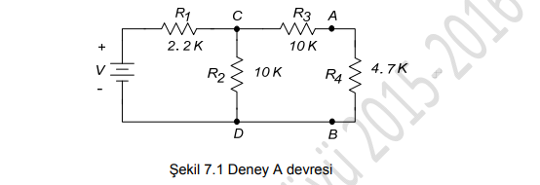

The measured open-circuit voltage represents the Thevenin equivalent voltage of the circuit. The equivalent resistance measured after deactivating the voltage source represents the Thevenin resistance. These values confirm that the original circuit can be replaced by a single voltage source in series with a resistance.

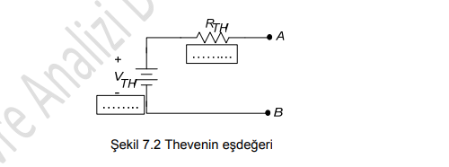

* Experiment B:

1. Determination of Norton Equivalent Procedure The circuit shown in Figure 7.3 was assembled using the given resistor values and a 9 V DC source.
2. Resistor R4 was removed.
3. The current between the open terminals was measured using the ammeter mode of the avometer. This value corresponds to the Norton current (IN).
4. The voltage source was deactivated and replaced with a short circuit.
5. The resistance between terminals A and B was measured using the ohmmeter mode of the avometer. This value corresponds to the Norton resistance (RN).
6. The results were recorded in the report.

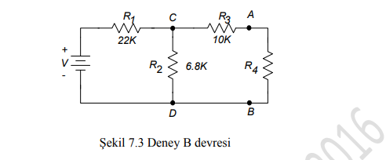

Analysis and Discussion According to circuit theory, the Norton resistance should be equal to the Thevenin resistance:

**𝑅 𝑁**

𝑅 𝑡 ℎ R N ​ =R th ​

The experimentally obtained values confirm this relationship. Furthermore, the Thevenin and Norton equivalents provide identical terminal behavior, demonstrating that both theorems are valid and interchangeable methods for simplifying complex linear circuits.

Minor discrepancies may be caused by resistor tolerances, internal resistance of the voltage source, and measurement inaccuracies.

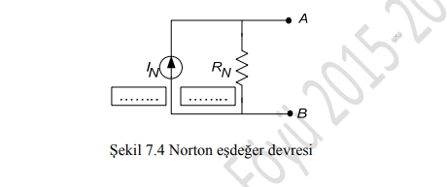

* SOLUTIONS

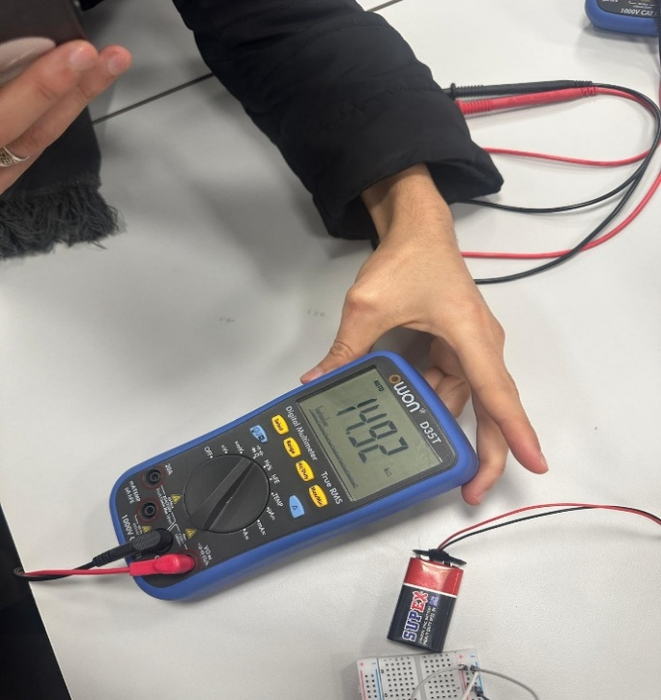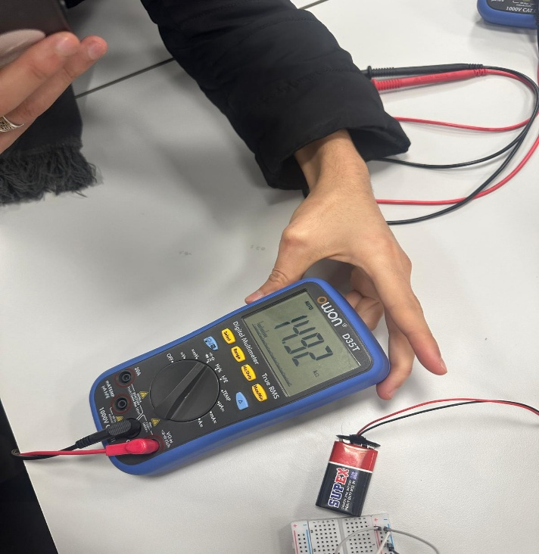

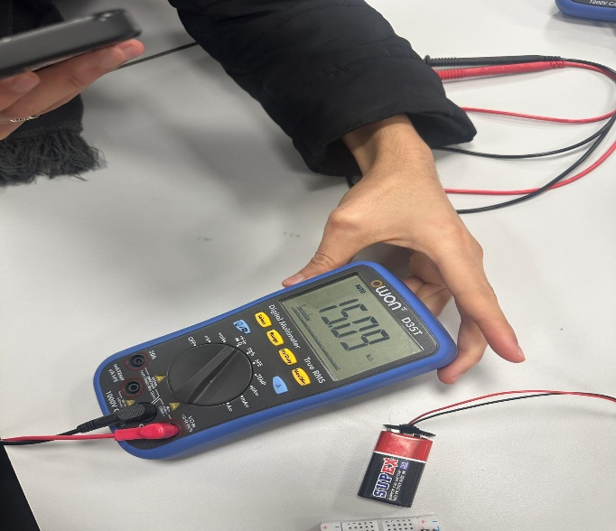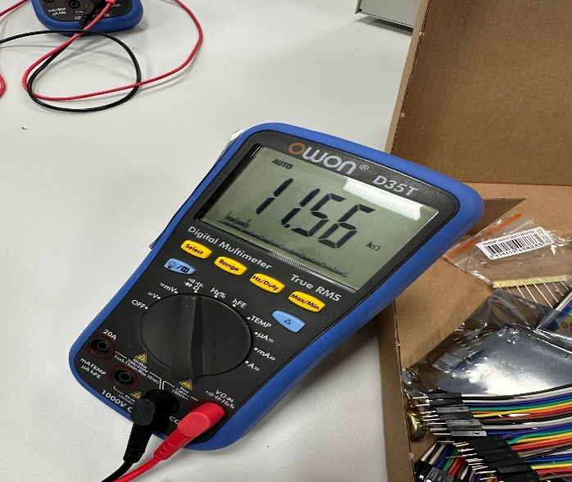

Conclusion In this experiment, Thevenin’s and Norton’s theorems were successfully verified through experimental measurements. The equivalent voltage, current, and resistance values were determined accurately, and the equivalence between the two methods was confirmed. These theorems provide powerful tools for simplifying and analyzing complex electrical circuits.

END OF THE PROJECT . CIRCUIT ANALYSIS REPORT

ABDELKERIM SEM ALI 2010205665